Part 1: Proof of Codepath registration and admission

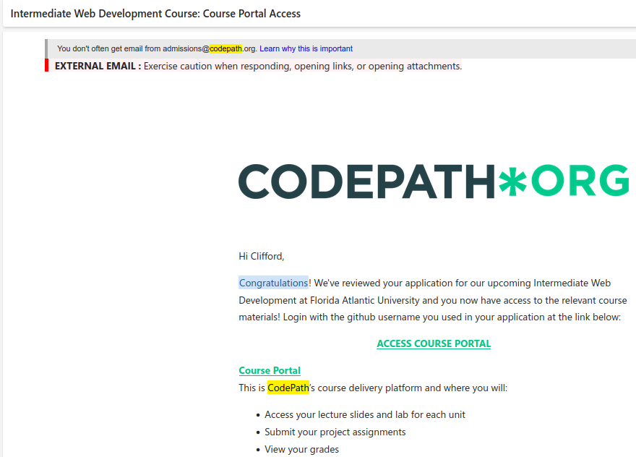
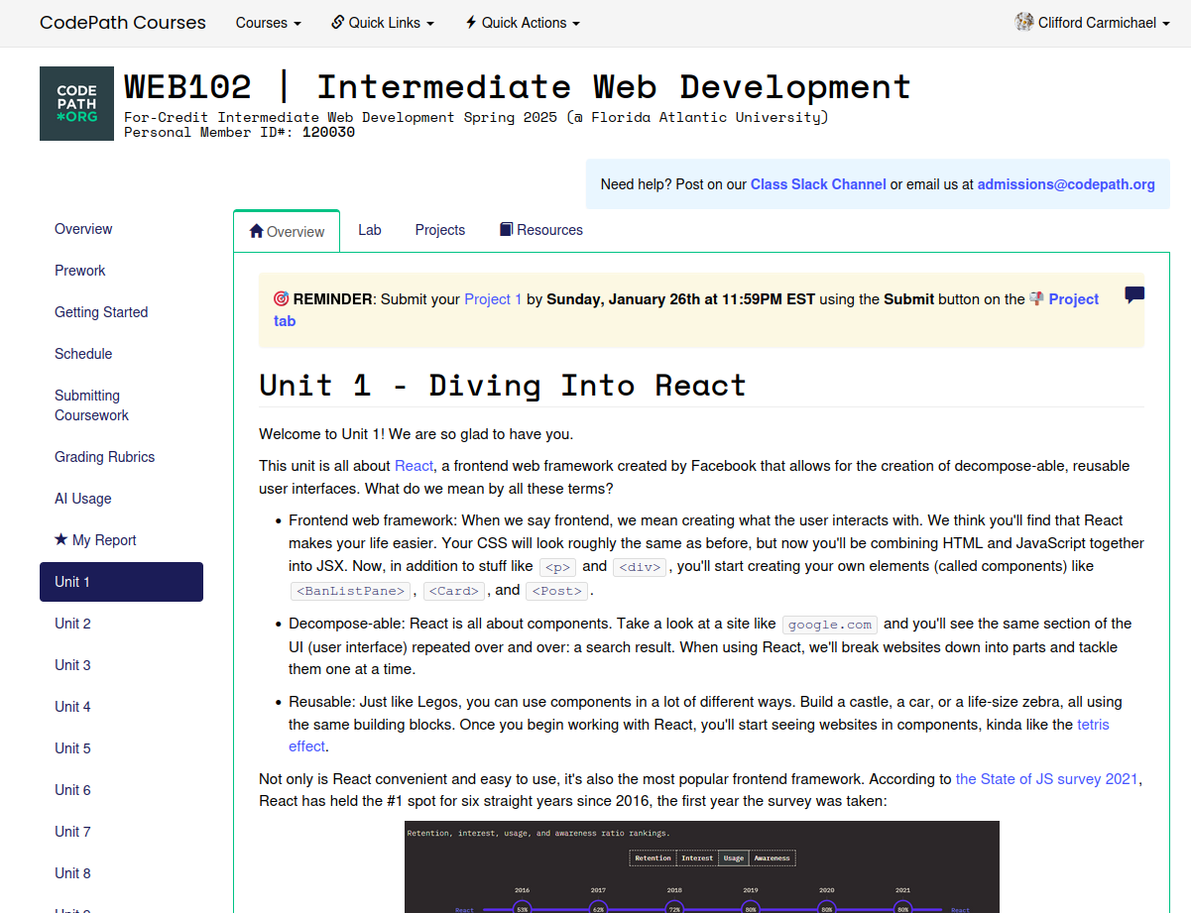

Part 2: Discord Introduction

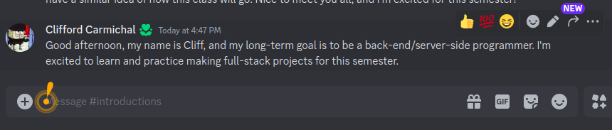

Part 3: Prework

Challenge 1: Forking github repository into local repository

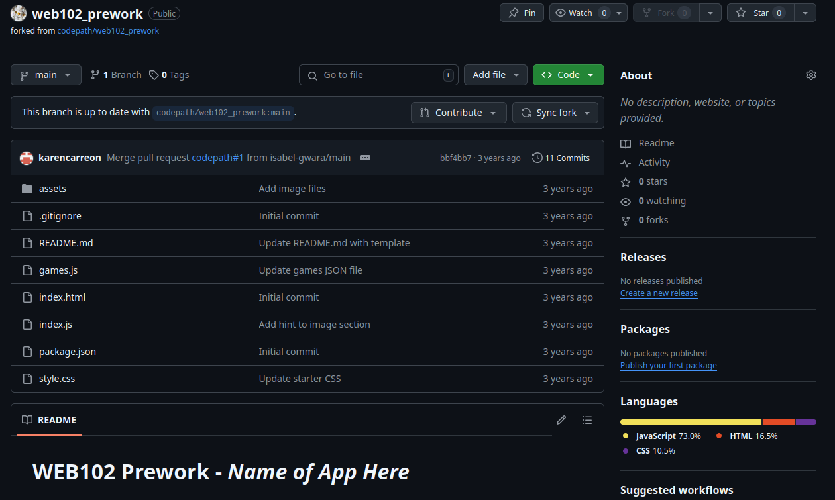

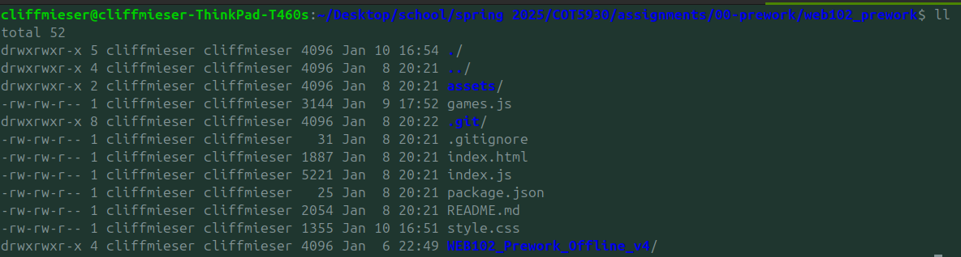
Image showing the repository has been cloned inside local machine.

Challenge 2: Reviewing starter code

Showing current state of index.html file:

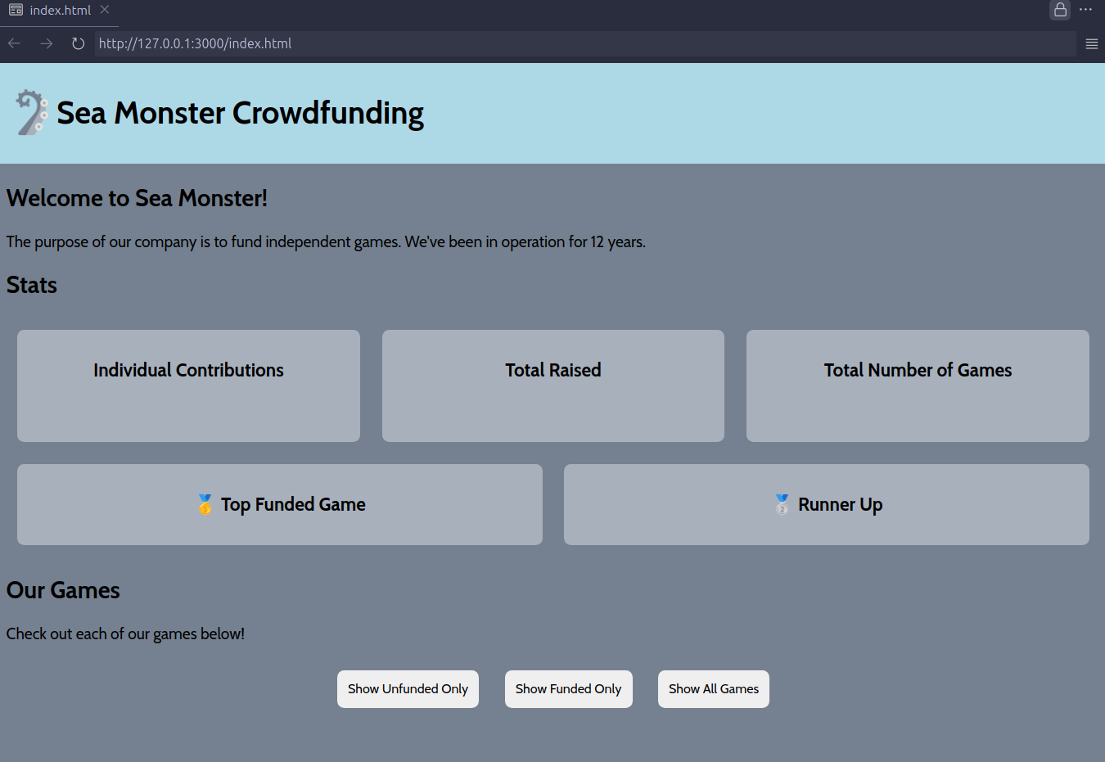

challenge 2.3:

Adding CSS rule for ‘stats-container’ and adding flexbox:
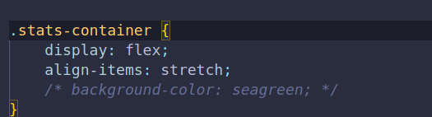

Set cursor to pointer and add box-shadow to ‘stats-container’ on hover :

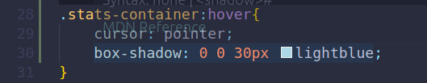

Challenge 3: Add data about each game as a card to the games-container
Step 1: loop over each item in the games argument

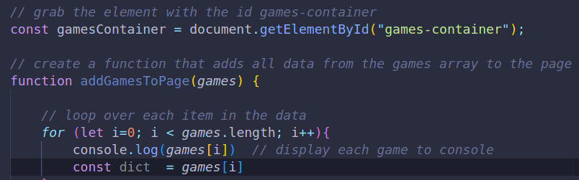

step 2: Create a div and add “game-card” to the class lists:
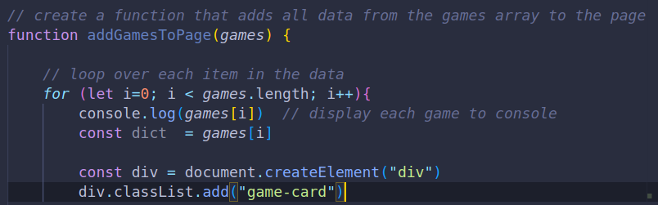
step 3: Create template literal that displays images of game and two attributes
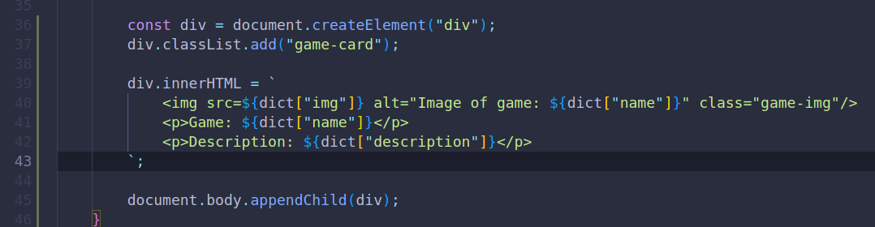
step 4: Append div so it appears under the our games heading:
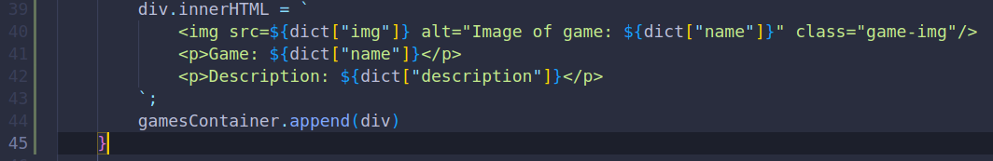

step 5: Call function to add the images to the page
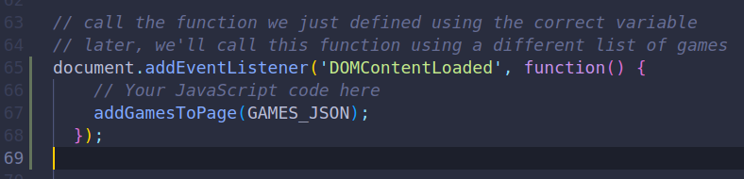
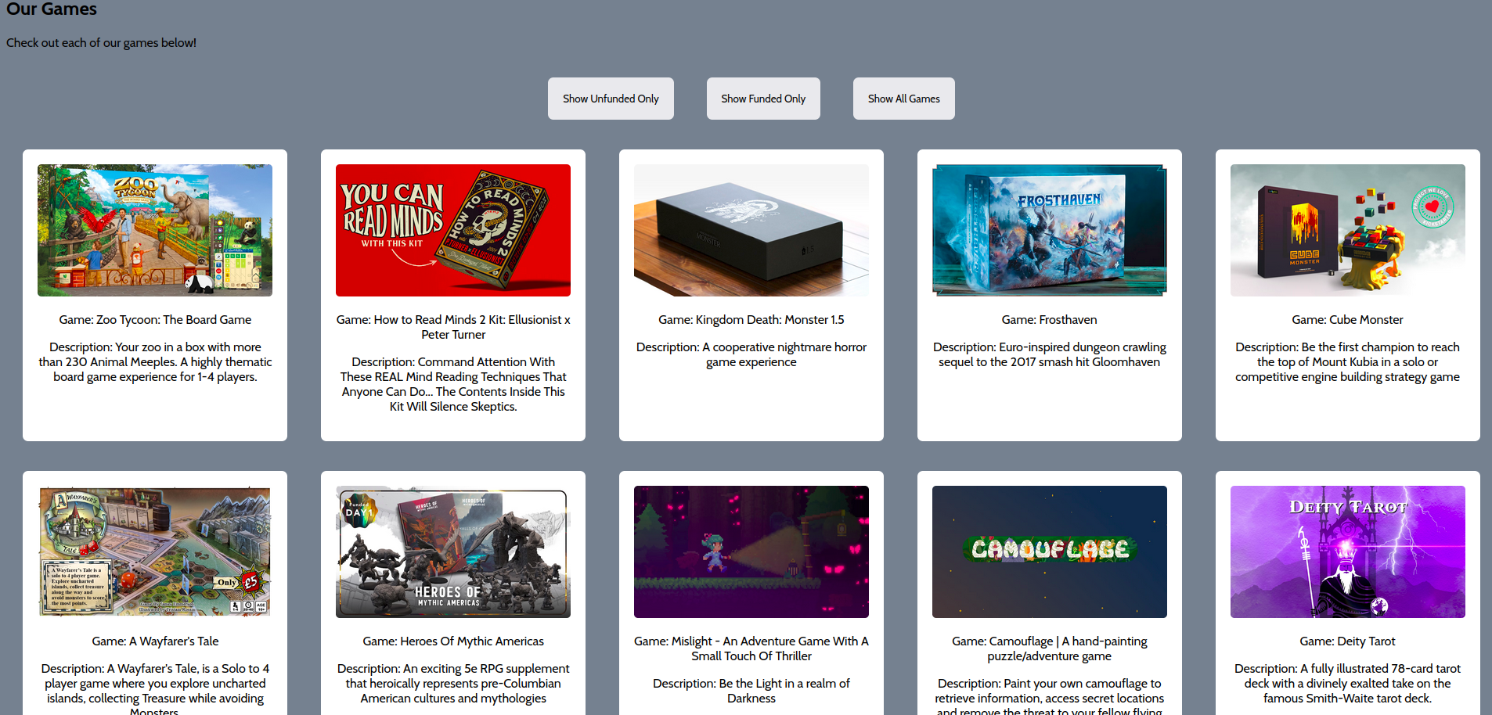

Challenge 4: Creating summary statistics at the top of page
Step 1: changing value of contributionsCard:

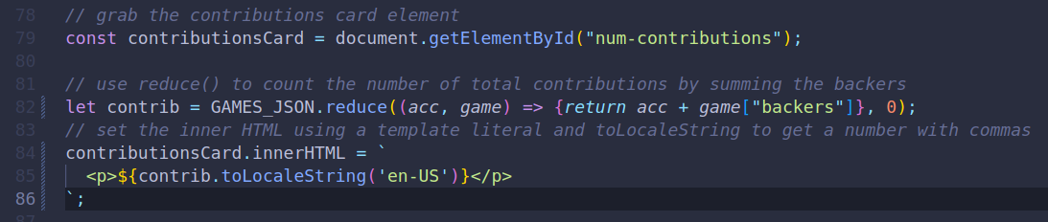
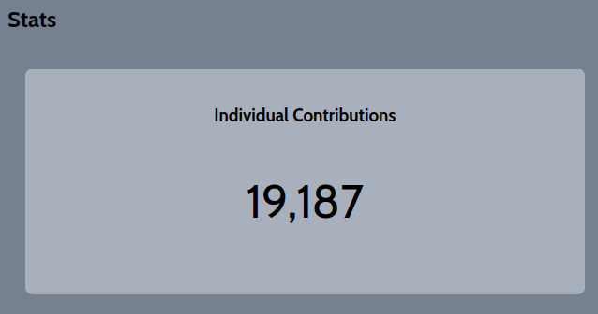

Step 2: Calculate total amount pledged across all games
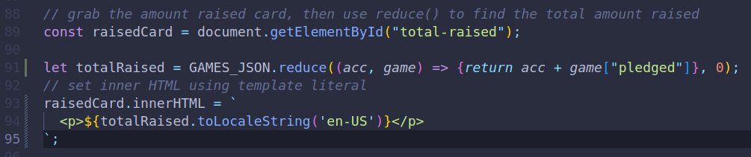
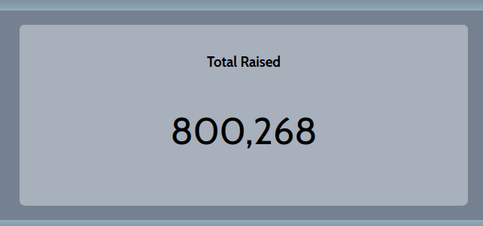

Step 3: display total number of games in gamesCard

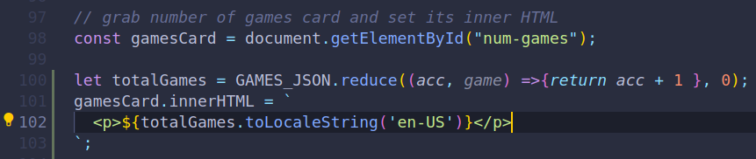
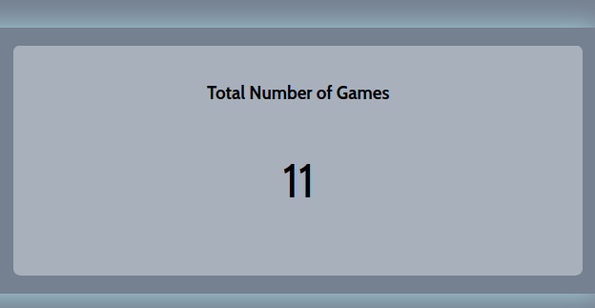
Result so far for challenge 4:
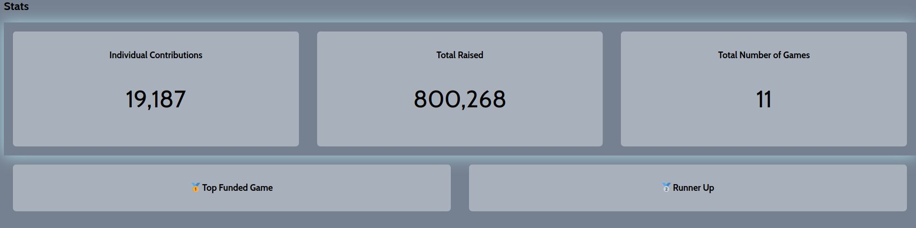

Challenge 5: Filter funded and unfunded games using functions

